**Chapter 04: Complex Integration and Cauchy’s Theorem**

Table of Contents

4.1 Complex Line Integrals 2

4.3 Connection Between Real and Complex Line Integrals 4

4.6 Simply and Multiply Connected Regions 5

## 4.1 Complex Line Integrals

Say we have a **curve**, $C$, and a function $f\left(z\right)$, which is **continuous** at all points of that curve. We can **subdivide** the curve $C$ into $n$ parts, with the $i$ th part being from the point $z_{i}$ to the point $z_{i+1}$. Thus, the points would be from $z_{0}$ to $z_{n}$.



For a particular subdivision, if we want to find the **area** of the curve beneath that subdivision, we can approximately say that it is equal to $f\left(z_{i}\right)\left(z_{i+1}-z_{i}\right)$, provided the subdivisions are sufficiently small to make this approximation.

Thus, if we want to know the area beneath the curve between $z_{0}$ to $z_{n}$,

$$S_{n}=\sum_{i=1}^{n}{f\left(z_{i}\right)\left(z_{i}-z_{i-1}\right)}$$

$z_{i}-z_{i-1}$ can also be written as $∆z_{i}$. Thus,

$$S_{n}=\sum_{i=1}^{n}{f\left(z_{i}\right)∆z_{i}}$$

If we now **increase $n$**  in such a way that even the largest possible value of $\left|∆z_{i}\right|$ begins to approach $0$, we can essentially say

$$S_{n}=\int_{a}^{b}{f\left(z\right)}dz=\int_{C}{f\left(z\right)dz}$$

where $a=z_{0}$ and $b=z_{n}$.

This is called the **complex line integral** of $f\left(z\right)$ along the curve $C$ or the **definite integral** of $f\left(z\right)$ from $a$ to $b$ along the curve $C$. In this case, $f\left(z\right)$ is said to be **integrable** along $C$. If $f\left(z\right)$ is analytical at all points of a region $R$, and $C$ lies within $R$, then $f\left(z\right)$ is continuous and therefore integrable along $C$.

## 4.3 Connection Between Real and Complex Line Integrals

Suppose $f\left(z\right)=u\left(x, y\right)+iv\left(x, y\right)=u+iv$. Then, we can express the complex line integral in terms of the **real line integrals**.

$$\int_{a}^{b}{f\left(z\right)}=\int_{a}^{b}{\left(u+iv\right)\left(dx+i dy\right)}=\int_{a}^{b}{\left(u dx-v dy\right)}+i\int_{a}^{b}{\left(v dx+u dy\right)}$$

## 4.6 Simply and Multiply Connected Regions

Say we have a region $R$ and a **simple closed curve**, $Γ$, which lies entirely within $R$.

The region $R$ is said to be **simply connected** if the curve $Γ$ can be shrunk to a point without leaving $R$. $R$ is said to be **multiply connected** if this is not true.

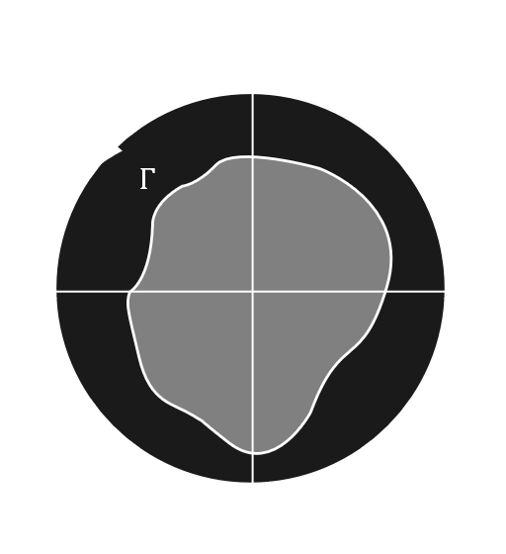

In the figure above, if the darkly shaded region is $R$ and the lightly shaded region is $Γ$, then $Γ$ can be shrunk to a point and will still be within $R$. Thus, $R$ is simply connected.

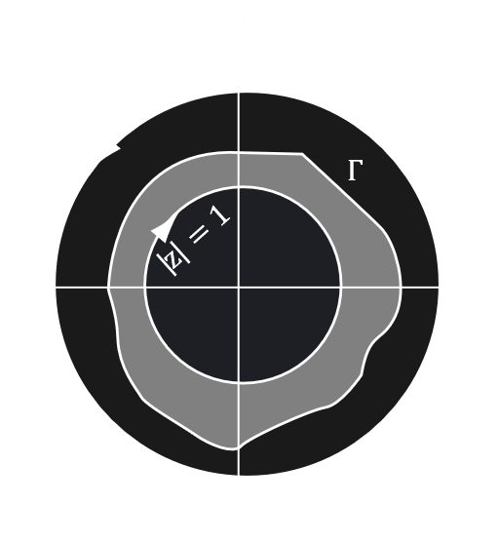

In this second graph, the darkly shaded region $R$ has a hole in the centre. Thus, $Γ$ cannot be shrunk to a point while still remaining within $R$, making $R$ multiply connected.

In simpler terms, $R$ is simply connected if it does not have any **holes** in it and multiply connected otherwise.